7.82: a) Yes; rather than considering arbitrary paths, consider that

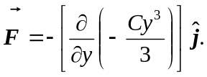

b) No; consider the same path as in Example 7.13 (the field is not the same). For this force, 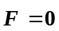 along Leg 1, 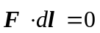 along legs 2 and 4, but 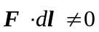 along Leg 3.

